|  |
| --- |
| CGI |
| LAB REPORT |
| LAB-2 |
|  |
| **SWET SHEERSH** |
| **7/24/2023** |

|  |
| --- |
| This report contains lab 2(1 to 5) codes and their output snapshots. |

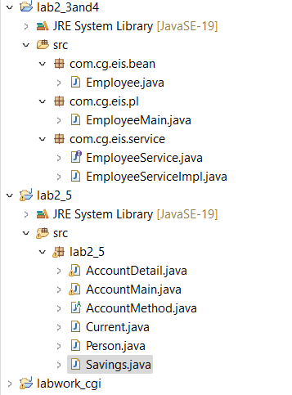

2.1.

package lab2_1;

import java.util.ArrayList;

import java.util.HashMap;

public class AccountMain {

public static void main(String[] args) {

System.out.println("Lab 2 -> Question No.:1-A");

System.out.println("+++++++++++++++++++++++++++");

// TODO Auto-generated method stub

AccountMethod method =new AccountMethod();

HashMap<String, AccountDetail> map=new HashMap<String, AccountDetail>();

//smith qAccount creation

AccountDetail detail1=new AccountDetail();

Person p=new Person();

p.setName("smith");

p.setAge(18);

detail1.setAccHolder(p);

detail1.setAccNum(method.generateAccNum());

detail1.setBalance(2000);

map.put("smith", detail1);

System.out.println(detail1);

System.out.println("--------------------------------------");

//kathy account creation

AccountDetail detail2=new AccountDetail();

Person p1=new Person();

p1.setName("kathy");

p1.setAge(22);

detail2.setAccHolder(p1);

detail2.setAccNum(method.generateAccNum());

detail2.setBalance(3000);

map.put("kathy", detail2);

System.out.println(detail2);

System.out.println("--------------------------------------");

System.out.println("Lab 1 -> Question No.:1-B");

System.out.println("+++++++++++++++++++++++++++");

map.get("smith").setBalance(method.deposit(2000,map.get("smith").getBalance()));

System.out.println(map.get("smith"));

System.out.println("--------------------------------------");

System.out.println("Lab 1 -> Question No.:1-C");

System.out.println("+++++++++++++++++++++++++++");

map.get("kathy").setBalance(method.withdraw(2000,map.get("kathy").getBalance()));

System.out.println(map.get("kathy"));

}

}

**package** lab2_1;

**public** **class** Person {

String name;

**float** age;

**public** String getName() {

**return** name;

}

**public** **void** setName(String name) {

**this**.name = name;

}

**public** **float** getAge() {

**return** age;

}

**public** **void** setAge(**float** age) {

**this**.age = age;

}

**public** Person() {

**super**();

// **TODO** Auto-generated constructor stub

}

**public** Person(String name, **float** age) {

**super**();

**this**.name = name;

**this**.age = age;

}

@Override

**public** String toString() {

**return** "Person [name=" + name + ", age=" + age + "]";

}

}

**package** lab2_1;

**import** java.util.Random;

**public** **class** AccountMethod {

**private** **final** **int** MIN_BALANCE=500;

**public** **int** deposit(**int** amount,**int** balance) {

**if** (amount >= 0) {

balance += amount;

**return** balance;

}

**return** balance;

}

**public** **int** withdraw(**int** amount,**int** balance) {

**if** (amount > 0 && balance - amount >= MIN_BALANCE) {

balance -= amount;

**return** balance;

}

**return** balance;

}

//account number

**public** String generateAccNum() {

Random random = **new** Random();

**return** String.*format*("%09d", random.nextInt(1000000000));

}

}

**package** lab2_1;

**import** java.util.Random;

**public** **class** AccountDetail {

//parameters

**private** String accNum;

**private** Person accHolder;

**private** **int** balance;

//getters and setters

**public** String getAccNum() {

**return** accNum;

}

**public** **void** setAccNum(String accNum) {

**this**.accNum = accNum;

}

**public** Person getAccHolder() {

**return** accHolder;

}

**public** **void** setAccHolder(Person accHolder) {

**this**.accHolder = accHolder;

}

**public** **int** getBalance() {

**return** balance;

}

**public** **void** setBalance(**int** balance) {

**this**.balance = balance;

}

//default constructor

**public** AccountDetail() {

**super**();

// **TODO** Auto-generated constructor stub

}

//Parameterized constructor

**public** AccountDetail(String accNum ,Person accHolder, **int** balance) {

**super**();

**this**.accNum = accNum;

**this**.accHolder = accHolder;

**this**.balance = balance;

}

//tostring

@Override

**public** String toString() {

**return** "AccountDetail [accNum=" + accNum + ", accHolder=" + accHolder + ", balance=" + balance + "]";

}

}

**Result:**

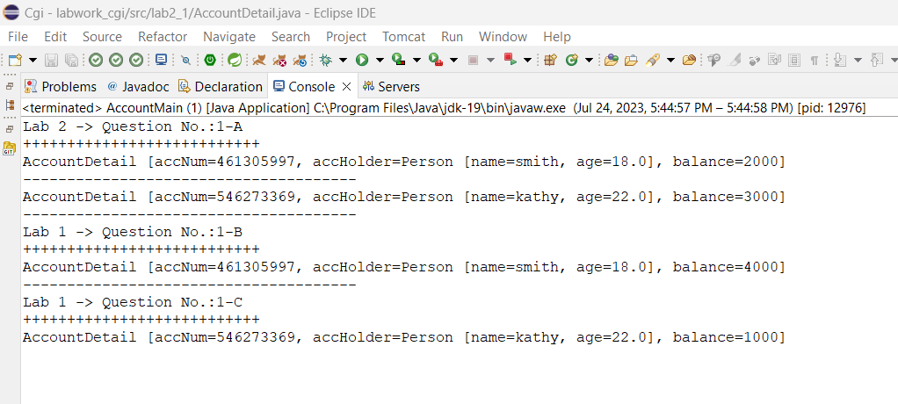

**2.2**

**package** lab2_2;

**import** java.util.Random;

**public** **class** AccountDetail {

//parameters

**private** String accNum;

**private** Person accHolder;

**private** **int** balance;

//getters and setters

**public** String getAccNum() {

**return** accNum;

}

**public** **void** setAccNum(String accNum) {

**this**.accNum = accNum;

}

**public** Person getAccHolder() {

**return** accHolder;

}

**public** **void** setAccHolder(Person accHolder) {

**this**.accHolder = accHolder;

}

**public** **int** getBalance() {

**return** balance;

}

**public** **void** setBalance(**int** balance) {

**this**.balance = balance;

}

//default constructor

**public** AccountDetail() {

**super**();

// **TODO** Auto-generated constructor stub

}

//Parameterized constructor

**public** AccountDetail(String accNum ,Person accHolder, **int** balance) {

**super**();

**this**.accNum = accNum;

**this**.accHolder = accHolder;

**this**.balance = balance;

}

//tostring

@Override

**public** String toString() {

**return** "AccountDetail [accNum=" + accNum + ", accHolder=" + accHolder + ", balance=" + balance + "]";

}

}

**package** lab2_2;

**import** java.util.Random;

**public** **class** AccountMethod {

**private** **final** **int** MIN_BALANCE=500;

**public** **int** deposit(**int** amount,**int** balance) {

**if** (amount >= 0) {

balance += amount;

**return** balance;

}

**return** balance;

}

**public** **int** withdraw(**int** amount,**int** balance) {

**if** (amount > 0 && balance - amount >= MIN_BALANCE) {

balance -= amount;

**return** balance;

}

**return** balance;

}

//account number

**public** String generateAccNum() {

Random random = **new** Random();

**return** String.*format*("%09d", random.nextInt(1000000000));

}

}

**package** lab2_2;

**public** **class** Current **extends** AccountMethod {

**private** **int** overdraftLimit;

**private** **final** **int** MIN_BALANCE=500;

**public** **int** getOverdraftLimit() {

**return** overdraftLimit;

}

**public** **void** setOverdraftLimit(**int** overdraftLimit) {

**this**.overdraftLimit = overdraftLimit;

}

@Override

**public** **int** withdraw(**int** amount, **int** balance) {

// **TODO** Auto-generated method stub

**if** (amount > 0 && balance - amount >= MIN_BALANCE && overdraftLimit>10) {

balance -= amount;

**return** balance;

}

**return** balance;

}

}

**package** lab2_2;

**public** **class** Person {

String name;

**float** age;

**public** String getName() {

**return** name;

}

**public** **void** setName(String name) {

**this**.name = name;

}

**public** **float** getAge() {

**return** age;

}

**public** **void** setAge(**float** age) {

**this**.age = age;

}

**public** Person() {

**super**();

// **TODO** Auto-generated constructor stub

}

**public** Person(String name, **float** age) {

**super**();

**this**.name = name;

**this**.age = age;

}

@Override

**public** String toString() {

**return** "Person [name=" + name + ", age=" + age + "]";

}

}

**package** lab2_2;

**public** **class** Savings **extends** AccountMethod {

**private** **final** **int** minimumBalance=500;

@Override

**public** **int** withdraw(**int** amount, **int** balance) {

// **TODO** Auto-generated method stub

**if** (amount > 0 && balance - amount >= minimumBalance) {

balance -= amount;

**return** balance;

}

**return** balance;

}

}

package lab2_2;

import java.util.ArrayList;

import java.util.HashMap;

public class AccountMain {

public static void main(String[] args) {

System.out.println("Lab 2 -> Question No.:1-A");

System.out.println("+++++++++++++++++++++++++++");

// TODO Auto-generated method stub

AccountMethod method =new AccountMethod();

HashMap<String, AccountDetail> map=new HashMap<String, AccountDetail>();

//smith qAccount creation

AccountDetail detail1=new AccountDetail();

Person p=new Person();

p.setName("smith");

p.setAge(18);

detail1.setAccHolder(p);

detail1.setAccNum(method.generateAccNum());

detail1.setBalance(2000);

map.put("smith", detail1);

System.out.println(detail1);

System.out.println("--------------------------------------");

//kathy account creation

AccountDetail detail2=new AccountDetail();

Person p1=new Person();

p1.setName("kathy");

p1.setAge(22);

detail2.setAccHolder(p1);

detail2.setAccNum(method.generateAccNum());

detail2.setBalance(3000);

map.put("kathy", detail2);

System.out.println(detail2);

System.out.println("--------------------------------------");

System.out.println("Lab 1 -> Question No.:1-B");

System.out.println("+++++++++++++++++++++++++++");

map.get("smith").setBalance(method.deposit(2000,map.get("smith").getBalance()));

System.out.println(map.get("smith"));

System.out.println("--------------------------------------");

System.out.println("Lab 1 -> Question No.:1-C");

System.out.println("+++++++++++++++++++++++++++");

map.get("kathy").setBalance(method.withdraw(2000,map.get("kathy").getBalance()));

System.out.println(map.get("kathy"));

}

}

Result:



**2.3**

**package** com.cg.eis.bean;

**public** **class** Employee {

**private** **int** id;

**private** String name;

**private** **double** salary;

**private** String designation;

**private** String insuranceScheme;

**public** Employee(**int** id, String name, **double** salary, String designation) {

**this**.id = id;

**this**.name = name;

**this**.salary = salary;

**this**.designation = designation;

**this**.insuranceScheme = findInsuranceScheme(salary, designation);

}

**public** **int** getId() {

**return** id;

}

**public** String getName() {

**return** name;

}

**public** **double** getSalary() {

**return** salary;

}

**public** String getDesignation() {

**return** designation;

}

**public** String getInsuranceScheme() {

**return** insuranceScheme;

}

**private** String findInsuranceScheme(**double** salary, String designation) {

**if** (salary > 50000 && designation.equalsIgnoreCase("SE")) {

**return** "Scheme A";

} **else** **if** (salary >= 30000 && salary <= 50000 && designation.equalsIgnoreCase("Programmer")) {

**return** "Scheme B";

} **else** **if** (salary < 30000 && designation.equalsIgnoreCase("Associate")) {

**return** "Scheme C";

} **else** {

**return** "No Scheme";

}

}

@Override

**public** String toString() {

**return** "Employee ID: " + id +

"\nName: " + name +

"\nSalary: " + salary +

"\nDesignation: " + designation +

"\nInsurance Scheme: " + insuranceScheme;

}

}

**package** com.cg.eis.service;

**import** com.cg.eis.bean.Employee;

**public** **interface** EmployeeService {

**void** getEmployeeDetails(Employee employee);

**void** displayEmployeeDetails(Employee employee);

}

**package** com.cg.eis.service;

**import** com.cg.eis.bean.Employee;

**public** **class** EmployeeServiceImpl **implements** EmployeeService {

@Override

**public** **void** getEmployeeDetails(Employee employee) {

// You can implement any additional logic for getting employee details here if needed.

// For this example, we are not doing anything extra in this method.

}

@Override

**public** **void** displayEmployeeDetails(Employee employee) {

System.***out***.println("Employee Details:");

System.***out***.println("-----------------");

System.***out***.println("ID: " + employee.getId());

System.***out***.println("Name: " + employee.getName());

System.***out***.println("Salary: " + employee.getSalary());

System.***out***.println("Designation: " + employee.getDesignation());

System.***out***.println("Insurance Scheme: " + employee.getInsuranceScheme());

System.***out***.println("-----------------");

}

}

package com.cg.eis.pl;

import java.util.Scanner;

import com.cg.eis.bean.Employee;

import com.cg.eis.service.EmployeeService;

import com.cg.eis.service.EmployeeServiceImpl;

public class EmployeeMain {

public static void main(String[] args) {

Scanner sc = new Scanner(System.in);

EmployeeService employeeService = new EmployeeServiceImpl();

System.out.println("Enter Employee Details:");

System.out.print("ID: ");

int id = sc.nextInt();

sc.nextLine(); // Consume the new line character left by nextInt()

System.out.print("Name: ");

String name = sc.nextLine();

System.out.print("Salary: ");

double salary = sc.nextDouble();

sc.nextLine(); // Consume the new line character left by nextDouble()

System.out.print("Designation: ");

String designation = sc.nextLine();

Employee employee = new Employee(id, name, salary, designation);

employeeService.getEmployeeDetails(employee);

System.out.println("\nInsurance Scheme Details:");

employeeService.displayEmployeeDetails(employee);

sc.close();

}

}

**Result:**

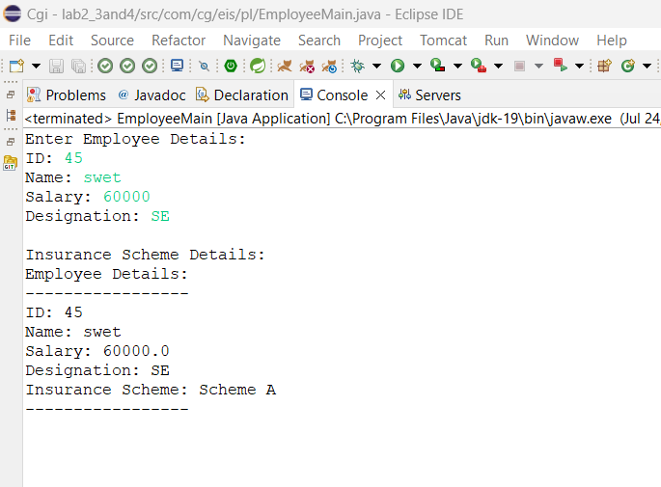

**2.4**

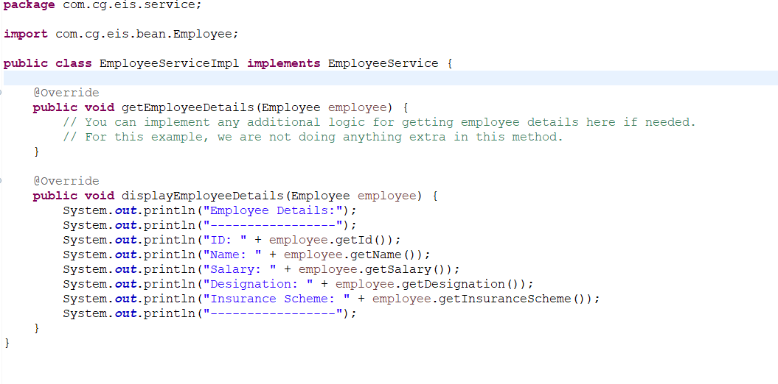

**2.5**

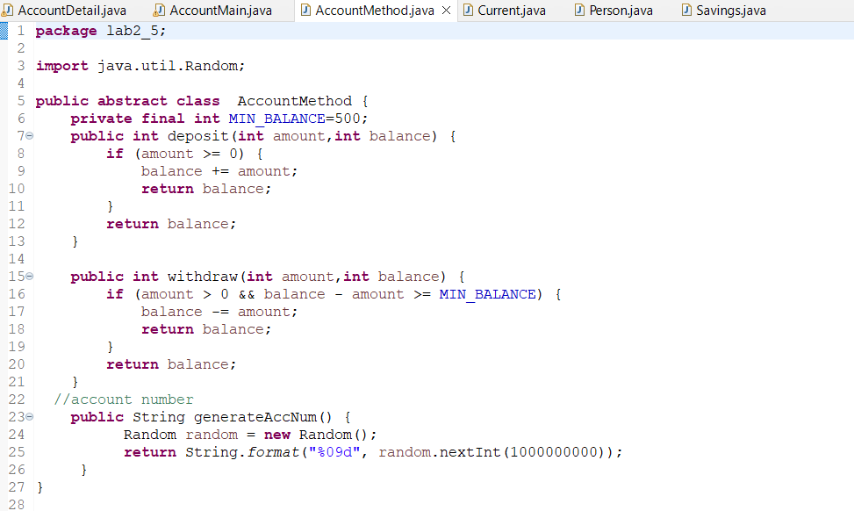

**package** lab2_5;

**import** java.util.Random;

**public** **class** AccountDetail {

//parameters

**private** String accNum;

**private** Person accHolder;

**private** **int** balance;

//getters and setters

**public** String getAccNum() {

**return** accNum;

}

**public** **void** setAccNum(String accNum) {

**this**.accNum = accNum;

}

**public** Person getAccHolder() {

**return** accHolder;

}

**public** **void** setAccHolder(Person accHolder) {

**this**.accHolder = accHolder;

}

**public** **int** getBalance() {

**return** balance;

}

**public** **void** setBalance(**int** balance) {

**this**.balance = balance;

}

//default constructor

**public** AccountDetail() {

**super**();

// **TODO** Auto-generated constructor stub

}

//Parameterized constructor

**public** AccountDetail(String accNum ,Person accHolder, **int** balance) {

**super**();

**this**.accNum = accNum;

**this**.accHolder = accHolder;

**this**.balance = balance;

}

//tostring

@Override

**public** String toString() {

**return** "AccountDetail [accNum=" + accNum + ", accHolder=" + accHolder + ", balance=" + balance + "]";

}

}

package lab2_5;

import java.util.ArrayList;

import java.util.HashMap;

public class AccountMain {

public static void main(String[] args) {

System.out.println("Lab 2 -> Question No.:1-A");

System.out.println("+++++++++++++++++++++++++++");

// TODO Auto-generated method stub

AccountMethod method =new Savings();

HashMap<String, AccountDetail> map=new HashMap<String, AccountDetail>();

//smith qAccount creation

AccountDetail detail1=new AccountDetail();

Person p=new Person();

p.setName("smith");

p.setAge(18);

detail1.setAccHolder(p);

detail1.setAccNum(method.generateAccNum());

detail1.setBalance(2000);

map.put("smith", detail1);

System.out.println(detail1);

System.out.println("--------------------------------------");

//kathy account creation

AccountDetail detail2=new AccountDetail();

Person p1=new Person();

p1.setName("kathy");

p1.setAge(22);

detail2.setAccHolder(p1);

detail2.setAccNum(method.generateAccNum());

detail2.setBalance(3000);

map.put("kathy", detail2);

System.out.println(detail2);

System.out.println("--------------------------------------");

System.out.println("Lab 1 -> Question No.:1-B");

System.out.println("+++++++++++++++++++++++++++");

map.get("smith").setBalance(method.deposit(2000,map.get("smith").getBalance()));

System.out.println(map.get("smith"));

System.out.println("--------------------------------------");

System.out.println("Lab 1 -> Question No.:1-C");

System.out.println("+++++++++++++++++++++++++++");

map.get("kathy").setBalance(method.withdraw(2000,map.get("kathy").getBalance()));

System.out.println(map.get("kathy"));

}

}

**package** lab2_5;

**import** java.util.Random;

**public** **abstract** **class** AccountMethod {

**private** **final** **int** MIN_BALANCE=500;

**public** **int** deposit(**int** amount,**int** balance) {

**if** (amount >= 0) {

balance += amount;

**return** balance;

}

**return** balance;

}

**public** **int** withdraw(**int** amount,**int** balance) {

**if** (amount > 0 && balance - amount >= MIN_BALANCE) {

balance -= amount;

**return** balance;

}

**return** balance;

}

//account number

**public** String generateAccNum() {

Random random = **new** Random();

**return** String.*format*("%09d", random.nextInt(1000000000));

}

}

**package** lab2_5;

**public** **class** Current **extends** AccountMethod {

**private** **int** overdraftLimit;

**private** **final** **int** MIN_BALANCE=500;

**public** **int** getOverdraftLimit() {

**return** overdraftLimit;

}

**public** **void** setOverdraftLimit(**int** overdraftLimit) {

**this**.overdraftLimit = overdraftLimit;

}

@Override

**public** **int** withdraw(**int** amount, **int** balance) {

// **TODO** Auto-generated method stub

**if** (amount > 0 && balance - amount >= MIN_BALANCE && overdraftLimit>10) {

balance -= amount;

**return** balance;

}

**return** balance;

}

}

**package** lab2_5;

**public** **class** Person {

String name;

**float** age;

**public** String getName() {

**return** name;

}

**public** **void** setName(String name) {

**this**.name = name;

}

**public** **float** getAge() {

**return** age;

}

**public** **void** setAge(**float** age) {

**this**.age = age;

}

**public** Person() {

**super**();

// **TODO** Auto-generated constructor stub

}

**public** Person(String name, **float** age) {

**super**();

**this**.name = name;

**this**.age = age;

}

@Override

**public** String toString() {

**return** "Person [name=" + name + ", age=" + age + "]";

}

}

**package** lab2_5;

**public** **class** Savings **extends** AccountMethod {

**private** **final** **int** minimumBalance=500;

@Override

**public** **int** withdraw(**int** amount, **int** balance) {

// **TODO** Auto-generated method stub

**if** (amount > 0 && balance - amount >= minimumBalance) {

balance -= amount;

**return** balance;

}

**return** balance;

}

@Override

**public** **int** deposit(**int** amount, **int** balance) {

// **TODO** Auto-generated method stub

**return** **super**.deposit(amount, balance);

}

@Override

**public** String generateAccNum() {

// **TODO** Auto-generated method stub

**return** **super**.generateAccNum();

}

}

Result:

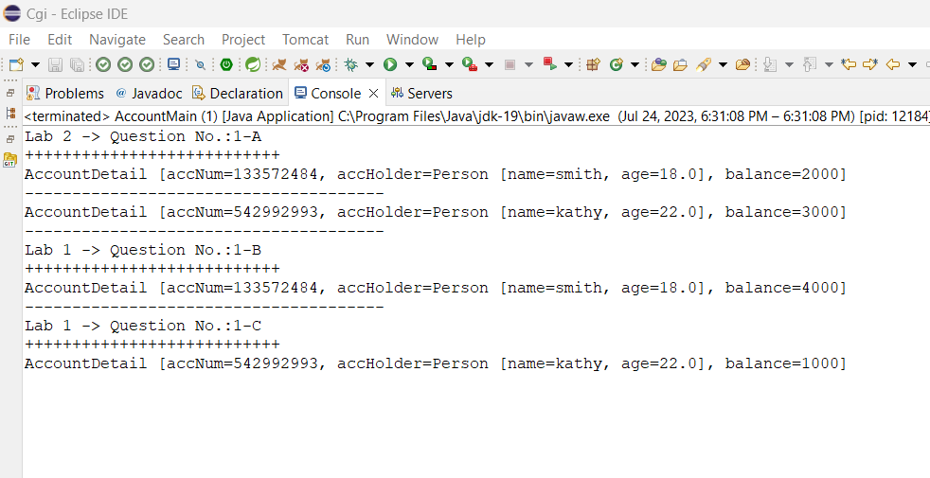

Thank You…